[ Travel & Tour Booking Website]

A Minor project submitted for the partial fulfillment of the requirements for the degree of
MASTER OF COMPUTER APPLICATION

Submitted By
Tanmay Samanta
Roll No: 18871022060 Session: 2022 - 2024
Kuntal Bhowmik
Roll No: 18871022048 Session: 2022 - 2024
Bishal Roy
Roll No: 18871022059 Session: 2022 - 2024



Techno College-Hooghly
Dharampur, Shantiniketan, Near Khadina more
G.T. Road, Chinsurah, Hooghly-712101
Phone: 033-2680-2389 / 6565
Website: www.technoindiahooghly.org Email: info@technoindiahooghly.org


Certificate

This is to certify that the project report titled “Travel & Tour Booking Website” has been prepared and submitted successfully by Tanmay Samanta, Kuntal Bhowmik and Bishal Roy using “MERN” as the MCA 3rd semester Minor project for the partial fulfillment of the requirements of the degree of MCA under MAKAUT, WB under the guidance of Assistant Professor Subhendhu Saha.

(Mr. Subhendhu Saha) Head of the Department, MCA
Project Supervisor Techno College Hooghly
ACKNOWLEDGEMENT
It is our pleasure to be indebted to various people, who directly or indirectly contributed in the development of this work and who influenced our thinking, behaviors, and acts during the course of study.
We express sincere gratitude to Dr. Mrinal Kanti Chakrabarty worthy Principal for providing us an opportunity to undergo this project at TECHNO COLLEGE HOOGHLY.
We are also thankful to Tapan Chakraborty and Raj Santra for their support, cooperation, and motivation provided to us during the training for constant inspiration, presence and blessings.
Lastly, we would like to thank the almighty and our parents for their moral support and our friends with whom we shared our day-to-day experience and received lots of suggestions that improved our quality of work.

Tanmay Samanta
_____________________________

Kuntal Bhowmik
_____________________________

Bishal Roy
_____________________________

TABLE OF CONTENT
Page No
- Abstract 1
- Introduction 1
- Objective and Scope of the project 1
- Theoretical Background 1-3
- Problem Definition 3-4
- System Analysis and Design via user requirements 4-5
- Feasibility study 6-7
- System Planning 8-10
Project life cycle 8
GRANT CHART 9
PERT CHART 10
- Software Requirement Specification 11-12
Functional and Non-functional Requirements 11
Development Platform 12
- Cost and Benefit analysis 13-14
- Software Design Specification 15-21
ERD 15-16
DFD 17-20
Use Case Diagram 21
- Database Schema 22
- Methodology For Testing 23-24
Testing strategies and test plan 23
Test Case and Test result 24
- User manual 25-37
- Conclusion 38
- Reference 39

PROJECT ABSTRUCT
As Tourism is becoming one of the fastest growing industries today, thus tourism is becoming more and more important. In particular, this Online Tourism System project in ReactJs focuses mainly on keeping track of customer’s tourism activities. “Tripify” is a online Tourism system whose main aim is to provide best tourism to customers. At the end of the study describes how tourism system follow certain stages.

INTRODUCTION
Tourisms are of two types 1) Domestic tourism and 2) International tourism. Nowadays tourism management system is developed to help in managing the tour service more efficiently. It can be used via internet connection also. It is a web-based system. Its objective is to deliver the online tourism service application into android platform. It is an attempt to provide the advantages of online booking of slot. The customer can book or register for tour through online and will get service by sitting at home.

OBJECTIVE AND SCOPE
The main objective of building this system is to handle the data management efficiently.
- To create web-based tourist management system.
- To manage all tourism related information.
- To provide emergency information or service in critical situation.
Scope of the project is very broad in terms of other systems. Few of them are:-
- Sender and receiver both will get SMS from the system.
- There is a huge collection of tourism category.
- Anyone can get emergency service.

THEORITICAL BACKGROUND
What is React?
React is a JavaScript library developed by Facebook, which among other thing, was used to build instagram.com. Its aim is to allow developers to easily create fast user interfaces for websites and applications alike. The main concept of React.js is virtual DOM.
Why use React?
- Easy to Learn:
Unlike Angular and Vue, learning React is like five-finger exercise, well of course on your keyboard! No wonder why, that’s a focal reason for React’s rapid adoption. It allows businesses to complete projects more quickly. React is more credible to be used by large firms as it is such a framework that is easy to get going with.
- Reusable Components:
ReactJS provides developers with reusable components that they can use to create new applications. Reusability is like a developer’s miracle cure. This platform enables developers to reuse any react component created for another application that performs the same function. As a result, development effort is reduced while flawless performance is maintained. One of the chief benefits of using React JS is that developers can reuse components as many times as they need to. Furthermore, changes made in one section of the application have no effect on other sections of the application. If you thought React was only for web development, you were dead wrong! Facebook has already developed the React Native framework for creating mobile apps for both the Android and iOS platforms.

Fast Rendering:
When developing a complex, high-load app, it is essential to define the structure of the app at the beginning as it can greatly influence the app’s performance. Simply put, As the DOM is tree-structured, even little changes at the root can cause major impacts on others. To solve this problem, Facebook has brought up a virtual DOM feature. Virtual DOM, which allows all modifications to be tested first for calculating risks. This approach contributes to app performance and a better user experience.

SEO Friendly:
Another benefit of React js is that it can cope with a common search engine failure to comprehend JavaScript-heavy apps. React significantly reduces load time of websites, which helps businesses to lead on the top spot-on Google’s Search Engine Result Page.
There are some of the frameworks that React possesses which improves SEO, one of them is NextJs. The rendering part of NextJs is moved to the server, removing the need for the client to process the data. Since the server pre-renders the pages before sending the final HTML to the client, there is less JS to load, which improves performance and SEO.

Strong Community Support:
One of the main reasons to choose React for your project is a strong community behind it. A massive range of individual React developers contribute to creating a more robust frontend framework on a daily basis.

Proficient Data Binding:
ReactJS lags behind one-way data binding. So that anyone can track all the changes made on particular portions of the data. This is often an illustration of its simplicity.

The Virtual DOM:

The virtual DOM (Document Object Model) is one of the most intriguing aspects of React. While creating an app with a lot of user interaction and data changes, you should think about how the structure of the app will affect speed. Extensive DOM manipulation can cause congestion in performance. Worse, As the DOM is tree-structured, even little changes at the root can cause major impacts on others.
A virtual DOM is used by React to solve this problem. This is a virtual version of the DOM, as the name implies. Any new view updates are made on the virtual DOM first, which is stored in memory rather than on your screen. It then finds the most efficient method of making these modifications, and only those changes are applied to the real DOM. This ensures that the real DOM is updated as quickly as possible, resulting in improved performance and a cleaner user experience overall.

Great Developer Tools:
React is a vast library for creating user interfaces, additionally it is supported by React Developer Tools which are browser extensions available for both Google Chrome and Mozilla Firefox.

PROBLEM DEFINITION
- Problems with conventional system.
- The information is very difficult to retrieve and to find particular information like – E.g. – To find out the customer’s history, the user has to go through various registers.
- The information generated by various transactions takes time and effort to be stored at right place.
- Preparation of accurate and prompt reports: - this become a difficult task as information is difficult to collect from various registers.
- Manual calculations are error prone and take a lot of time this may result in incorrect information. For example, calculation of customer’s payment history based on various booking.

SYSTEM ANALYSIS AND DESIGN VIA USER REQUIREMENT
All possible requirements of the system to be developed are captured in this phase and documented in a requirement specification document. The requirement specifications from first phase are studied in this phase and the system design is prepared. This system design helps in specifying hardware and system requirements and helps in defining the overall system architecture.
System Analysis:
The objective of the system analysis activity is to develop structured system specification for the proposed system. The structured system specification should describe what the proposed system would do; independent of the technology, which will be used to implement these requirements. The structured system specification will be used to implement these requirements. The structured system specification will be called the essential model (also known as logical model).
The essential model may itself consist of multiple models, modeling different aspect of the system. The data flow diagrams may model the data and their relationships and the state transition diagram may model time dependent behavior of the system. The essential model thus consists of the following: -

- Context diagram
- Labelled data flow diagrams
- Process specification for elementary bubbles
- Data dictionary for the flow and stores on the DFDs.

System Design:
System design involves transformation of the user implementation model into software design.
The design specification of the proposed system consists of the following: -
  - Database scheme
  - Structure charts
  - Pseudo codes for the modules in structure charts

FEASIBILITY STUDY
Why feasibility study required?
Feasibility study is made to see if the project on completion will serve the purpose the organization for the amount of work. Effort and the time that spend on it. Feasibility study lets the developer foresee the future of the project and the usefulness. A feasibility study of a system proposal is according to its workability, which is the impact on the organization, ability to meet their user needs and effective use of resources. Thus when a new application is proposed it normally goes through a feasibility study before it is approved for development. The document provides the feasibility of the project that is being designed and lists various area that were considered very carefully during the feasibility study of this project such as Technical, Economic, Social and Operational feasibilities.
- technical feasibility-

The engineering feasibility of the project in viewed in the technical feasibility. Certain important engineering aspects are covered which are necessary for the designing of the project like civil, structural and other relevant aspects. Technical capability of the projected technologies and the capabilities of the personnel to be employed in the project are considered. In certain examples especially when projects are in third world countries, technology transfer between cultures and geographical areas should be analyzed.
- Economic Feasibility-

Economic feasibility refers to the feasibility of the considered project to produce economic benefits. A benefit-cost analysis is needed. Furthermore, the economic feasibility of a project can also be evaluated by a breakeven analysis. In order to facilitate the consistent basis for the evaluation, thetangible and intangible facet of a project must be translated into the economic terms. Economic feasibility is critical even when the project is non-profit in nature.

- OPERATIONAL FEASIBILITY-
Operational feasibility is dependent on human resources available for the project and involves projecting whether the system will be used if it is developed and implemented.
Operational feasibility is a measure of how well a proposed system solves the problems, and takes advantage of the opportunities identified during scope definition and how it satisfies the requirements identified in the requirement analysis phase of system development.
Operational feasibility reviews the willingness of the organization to support the proposed system. This is probably the most difficult of the feasibilities to gauge. In order to determine this feasibility, it is important to understand the management commitment to the proposed project. If the request was initiated by management, it is likely that there is management support and the system will be accepted and used. However, it is also important that the employee base will be accepting of the change.
- Social Feasibility-
The affect that a proposed project may have on the social system in the project environment is addressed in the social feasibility. It may happen that particular category of employees may be short or not available as a result of ambient social structure. The influence on the social status of the participants by the project should be evaluated in order to guarantee compatibility. It must be identified that employees in the particular industries may have specific status symbols within the society.

SYSTEM PLANNING
- Project life cycle-

This Document plays a vital role in the development life cycle (SDLC) as it describes the complete requirement of the system. It is meant for use by the developers and will be the basic during testing phase. Any changes made to the requirements in the future will have to go through formal change approval process. WATER FALL MODEL was being chosen because all requirements were known beforehand and the objective of our software development is the computerization/automation of an already existing manual working system.
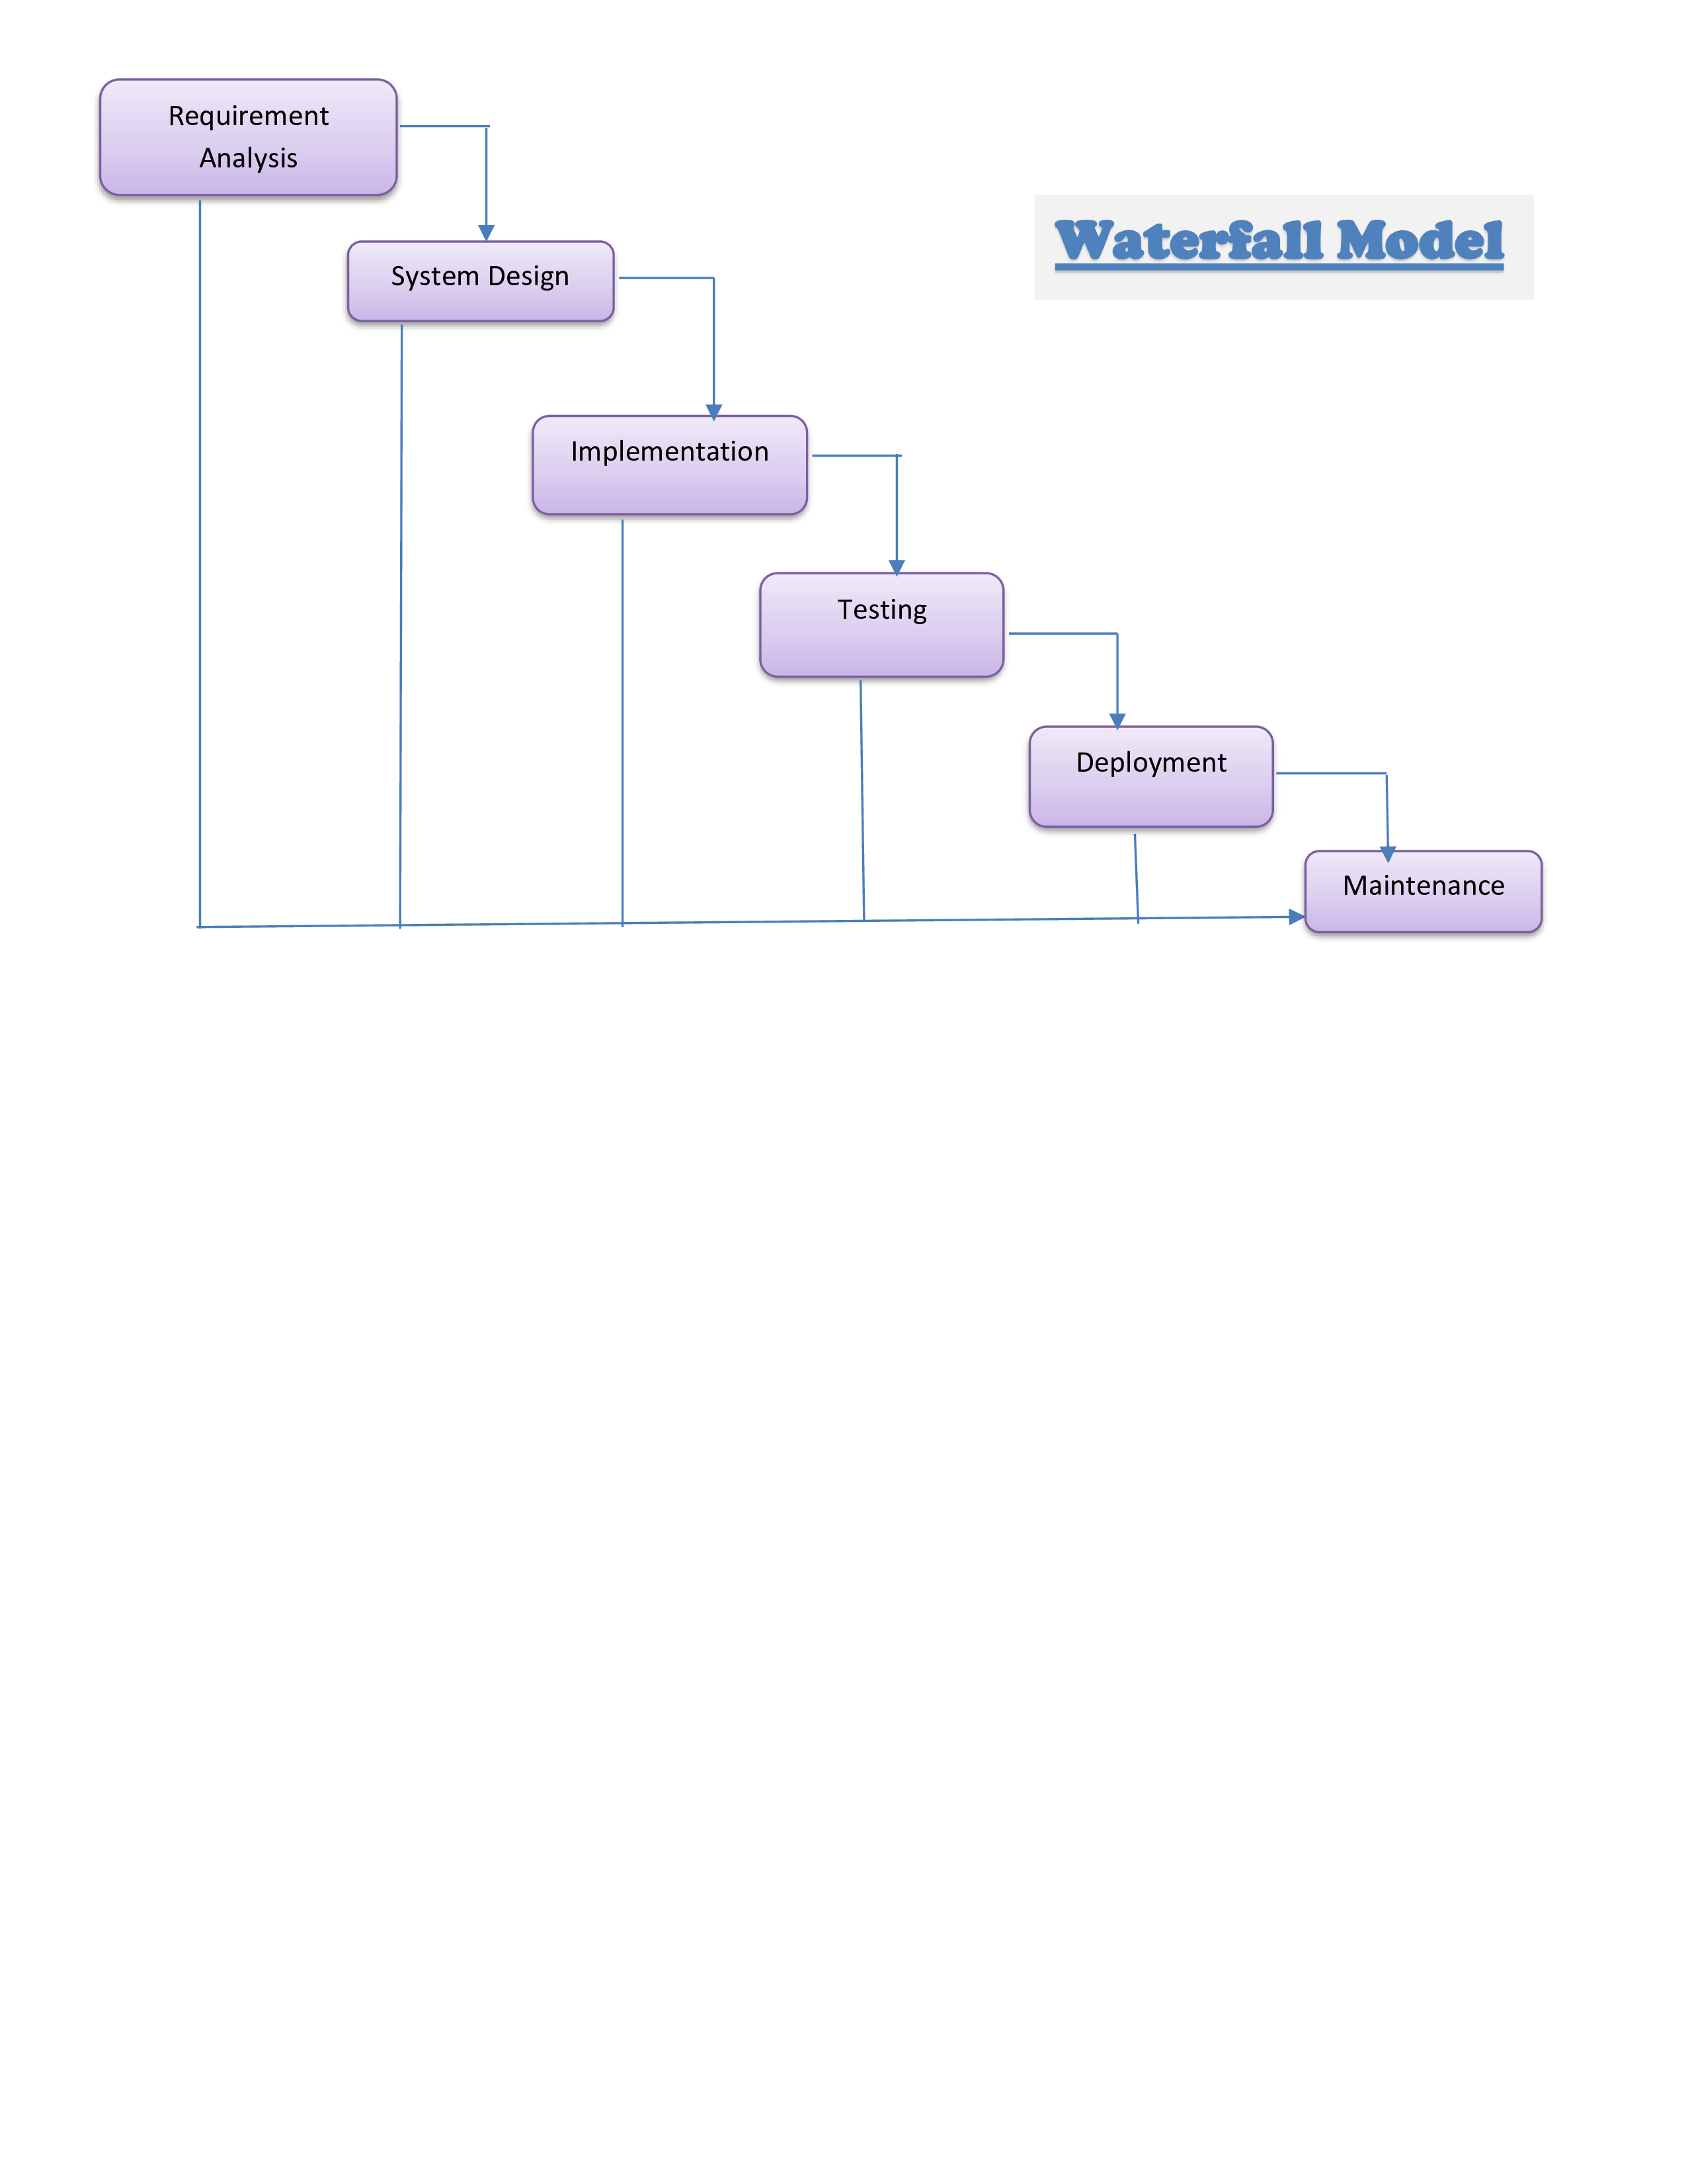

The developer is responsible for:

• Developing the system, which meets the SRS and solving all the requirements of the system.
• Demonstrating the system and installing the system at client's location after the acceptance testing is successful.
• Submitting the required user manual describing the system interfaces to work on it and also the documents of the system.
• Conducting any user training that might be needed for using the system.
• Maintaining the system for a period of one year after installation.

- Gantt chart
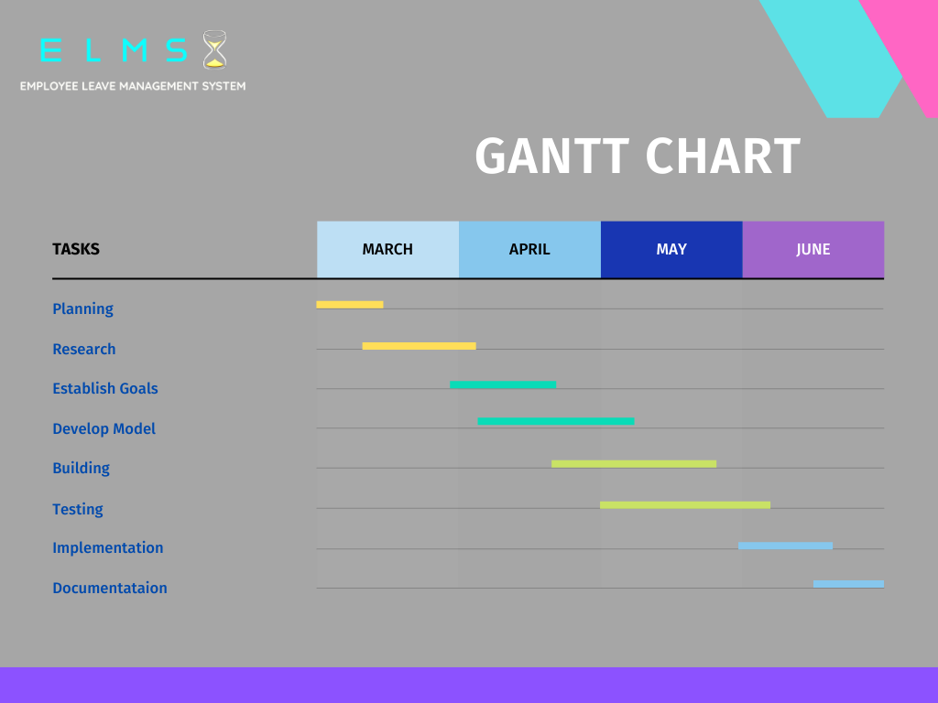

- PERT CHART-

REQ. ANALYSIS
17-03-2022

IDEA GATHERD
06-03-2022

END
10-06-2022
START
02-03-2022
TESTING
31-05-2022
DESIGN
20-03-2022

COPY EDIT SOFTWARE
08-06-2022
WRITE MANUL
03-06-2022

SOFTWARE REQUIREMENT SPECIFICATION
- Functional Requirements-

Modules: The modules used in this software are as follows:
- Home: On the home page we are going to fetch all places that we can book. when we click a specific place, we can see more information about this place. On the top-right corner, there is a user button for login or register.

- Register: Collects information from individuals who want to register for service.

- Login: Allows users to access the website by verifying their identity.

- Account: This page contains the information about logged-in user.

- My Accommodation: We can see all the places we have added.

- My Booking: Record of all the places you have booked.

- New Place: As an admin, you can add required information for a place.
.

- Non-functional requirements-
- Usability Requirement: The system shall allow the users to access the system from any browsers, no special training is required. The system user friendly and the system is written in simple English.

- Availability Requirement: The system is available 100% for the user and is used by 24 hours a day and 365 days a year. The system shall be operational 24 hours a day and 7 days a week.

- Accuracy: The system should accurately provide real time information taking into consideration various issues. The system shall provide 100% access reliability.

- Performance Requirement: The information is refreshed at regular intervals depending upon whether some updates have occurred or not. The system shall respond the member in less than 2 seconds.

- Security Requirement: System will use a secured database and the system will have different users and each user has different types of constraints. Only admins have the rights to update database information of other users.

- Reliability Requirement: The system has to be 100% reliable due to the importance of data and the damages that can be caused by incorrect data. The system will run 7 days a week and 24 hours a day.

Development Platform-
- HARDWARE REQUIREMENTS

HARDWARE REQUIREMENTS
Processor | Intel Pentium IV 2.0 GHz and above
RAM | 128 MB and above
Disk space | 1 GB and above
Others | Standard Input Output (Mouse and  Keyboard)

- SOFTWARE REQUIREMENTS
SFTWARE REQUIREMENTS
Web Browser | Internet Explorer, Google  Chrome
Operating System | Windows 10/ Windows 11
Framework | MERN
Database | MongoDB

COST AND BENEFIT ANALYSIS
When a project is developed costs are incurred through its lifecycle. Benefits are realized in the form of reduced operation costs, improved corporate image, staff efficiency or revenues.
Cost and benefit analysis is a procedure that gives a picture of the various costs, benefits & rules associated with a system. The determination of costs & benefits entails the following steps.
- Costs & benefits pertaining to the project are identified.

- The various costs & benefits are categorized for analysis.

- An evaluation method is selected.

- The results of analysis are interpreted.

Costs are identified as tangible, intangible costs, direct and indirect costs, fixed and variable costs.
Cost Estimation of the Project:

- We are using COCOMO in this project to calculate the cost estimation.
- COCOMO is one of the most widely used software estimation models in the world
- It was developed by Barry Boehm in 1981
- COCOMO predicts the effort and schedule for a software product development based on inputs relating to the size of the software and a number of cost drivers that affect productivity.

- COCOMO has three different models that reflect the complexity:
- The Basic Model
- The Intermediate Model
- And the Detailed Model
We are using Basic COCOMO as Semi-detached for the rough estimation of the Project Cost.
A software project is said to be a Semi-detached type if the vital characteristics such as team-size, experience, knowledge of the various programming environment lie in between that of organic and embedded. The projects classified as Semi-Detached are comparatively less familiar and difficult to develop compared to the organic ones and require more experience and better guidance and creativity. Eg: Compilers or different Embedded Systems can be considered of Semi-Detached type.
Effort = a*(KLOC)^{b}person-month
TDev = c*(Effort)^{d} month
Person = Effort/TDev
- The total estimated lines of code for the project = 50,000 LOC.
- Personnel experience multiplier = 1.1.
- Complexity multiplier = 1.05.
- Development flexibility multiplier = 1.08.
- Average cost per person-month = $0.

Here is the calculation of the COCOMO model with the given parameters:

Calculate the effort
Effort = (5,000 LOC * 1.1 * 1.05 * 1.08) = 6,696 person-months

Calculate the development time
Development time = 2.52 * (6,696 person-months)^0.3 = 31.6 months

Calculate the cost
Cost = (31.6 months * $1) = $31.6

Therefore, the total estimated cost of the project using the COCOMO model is $31.6.

SOFTWARE DESIGN SPECIFICATION
Entity Relationship Diagram-

An ER diagram shows the relationship among entity sets. An entity set is a group of similar entities and these entities can have attributes. In terms of DBMS, an entity is a table or attribute of a table in database, so by showing relationship among tables and their attributes, ER diagram shows the complete logical structure of a database. Lets have a look at a simple ER diagram to understand this concept. Facts about ER Diagram Model: ER model allows you to draw Database Design It is an easy to use graphical tool for modeling data Widely used in Database Design It is a GUI representation of the logical structure of a Database It helps you to identifies the entities which exist in a system and the relationships between those entities.

Entity

Relationship

Attribute

E-R Diagram


booking_id

name
email
name
email
user_id
password
user_id
password
User
Admin
place_id

1
1

user _id

place_id

checkIn

checkOut
Booking
Add Places
user_id

name

phone

N
N

price

Place


place_id

price

maxGues
title

checkOut
address

checkIn
photos

perks
description extraInfo
perks

Data Flow Diagram-

A Data Flow Diagram (DFD) is a diagram that describes the flow of data and the processes that change data throughout a system. A structured analysis and design tool that can be used for flowcharting in place of or in association with information. Oriented and process-oriented system flowcharts. When analysts prepare the Data Flow Diagram, they specify the user needs at a level of detail that virtually determines the information flow into and out of the system and the required data resources. This network is constructed by using a set of symbols that do not imply physical implementations. The Data Flow Diagram reviews the current physical system, prepares input and output specification, specifies the implementation plan etc.
Four basic symbols are used to construct data flow diagrams. They are symbols that represent data source, data flows, and data transformations and data storage. The points at which data are transformed are represented by enclosed figures, usually circles, which are called nodes.
Data Flow Diagram Symbols: -

Source or Destination of Data

0 level DFD - The 0 level dfd known as context level data flow diagram. The context level data flow diagram (dfd) is describing the whole system. The (o) level dfd describe the all-user modules who run the system. Below context level data flow diagram of Nursery management system project shows the one Admin user can operate the system. Admin do all activities after login to system.

CUSTOMER
Registration
Add Travel Package

ADMIN
Login Credential
View Place
Book Place
TOUR &TRAVEL Management System
Response
Booking Details

1st level DFD -The Admin side DFD describe the functionality of Admin. Admin is a responsible person who run the project. After login to system admin can first Add Tour Detail by date wise. and admin can manage tour days and tour payment detail.

Registration Details Register
Register Action

Successful Registered
USER
VIEW ACCOUNT
LOGIN

View Place
Login Details

User_tbl Successfully
Logged in
BOOKING

Formatted Data
View BOOKING

Retrieved Data

Booking_tbl

LOGIN
Login Details
USER

Successfully Logged In

Manage Modules
Check Roles of Access
Manage Roles of User
Manage Booking Details
Manage Package Details
Manage Customer Details
Manage Tour Report
ADMIN
Login to System
Check Credential
Use Case Diagram -
A use case diagram at its simplest is a representation of a user's interaction with the system that shows the relationship between the user and the different use cases in which the user is involved. A use case diagram can identify the different types of users of a system and the different use cases and will often be accompanied by other types of diagrams as well.
So only static behavior is not sufficient to model a system rather dynamic behavior is more important than static behavior. In UML there are five diagrams available to model dynamic nature and use case diagram is one of them. Now as we have to discuss that the use case diagram is dynamic in nature there should be some internal or external factors for making the interaction.
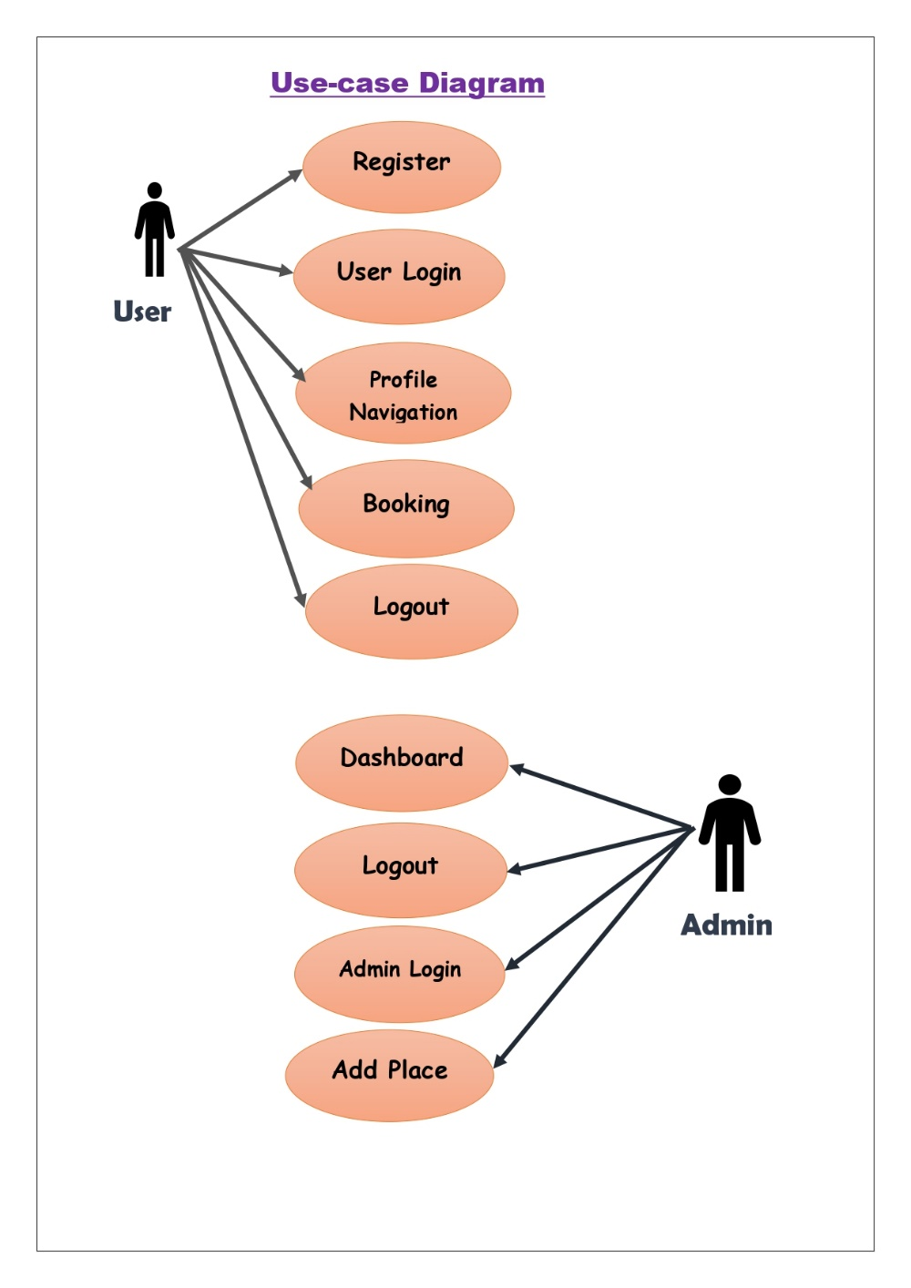

Database Schema

Place
Name | Type | Null | Default | Unique
place_id | object | No | None | TRUE
title | string | Yes | None | FALSE
address | string | No | None | FALSE
photos | [string] | Yes | None | FALSE
description | String | Yes | None | FALSE
photos | [String] | Yes | None | FALSE
perks | [String] | Yes | None | FALSE
extraInfo | String | Yes | None | FALSE
checkIn | Number | No | None | FALSE
checkOut | Number | No | None | FALSE
maxGuests | Number | No | None | FALSE
price | Number | No | None | FALSE

Booking
Name | Type | Null | Default | Unique
booking_id | object | No | None | TRUE
place_id | object | No | None | TRUE
user_id | object | No | None | TRUE
checkIn | Number | No | None | FALSE
checkOut | Number | No | None | FALSE
name | String | No | None | FALSE
phone | String | No | None | FALSE
price | Number | Yes | None | FALSE

Admin
Name | Type | Null | Default | Unique
user_id | object | No | None | TRUE
name | string | No | None | FALSE
email | string | No | None | FALSE
password | string | No | None | TRUE

User
Name | Type | Null | Default | Unique
user_id | object | No | None | TRUE
name | string | No | None | FALSE
email | string | No | None | FALSE
password | string | No | None | TRUE

Methodology used for testing and some testing results
Testing strategies and test plan -
The objective of the testing is test the written program. Testing is done at various levels to ensure the quality of the software develops. The user test the system to verify that the system function as specified. Once it is verified the system is ready for lunch in web. So, we test our product through different methods of testing. These are:-
1.Black Box Testing
Black box testing treats the software as a "black box"—without any knowledge of internal implementation. Black box testing methods include: equivalence partitioning, boundary value analysis, all-pairs testing, fuzz testing, model-based testing, traceability matrix, exploratory testing and specification-based testing.

Specification-based testing
Specification-based testing aims to test the functionality of software according to the applicable requirements.[21] Thus, the tester inputs data into, and only sees the output from, the test object. This level of testing usually requires thorough test cases to be provided to the tester, who then can simply verify that for a given input, the output value (or behavior), either "is" or "is not" the same as the expected value specified in the test case.
Specification-based testing is necessary, but it is insufficient to guard against certain risks.

2.Black Box Testing
White box testing is when the tester has access to the internal data structures and algorithms including the code that implement these.
Types of white box testing:
The following types of white box testing exist:

- API testing (application programming interface) - Testing of the application using Public and Private APIs
- Code coverage - creating tests to satisfy some criteria of code coverage (e.g., the test designer can create tests to cause all statements in the program to be executed at least once)
- Fault injection methods - improving the coverage of a test by introducing faults to test code paths
- Mutation testing methods.
- Static testing - White box testing includes all static testing

Test coverage
White box testing methods can also be used to evaluate the completeness of a test suite that was created with black box testing methods. This allows the software team to examine parts of a system that are rarely tested and ensures that the most important function points have been tested.[24]
Two common forms of code coverage are:

- Function coverage, which reports on functions executed
- Statement coverage, which reports on the number of lines executed to complete the test
They both return a code coverage metric, measured as a percentage.
Test case and test result
Test cases | Expected outcome | Exact outcome | Result
1. Login using correct credentials. | Login successful. | Login successful. | Pass
2. Attempt to login using wrong password | Login failed with error message “Wrong password” | Login failed with error message “Wrong password” | Pass
3. Attempt to login using wrong email. | Login failed with error message “Please register” | Login failed with error message “Please register” | Pass
4. Attempt to register using registered email. | Login failed with error message “Already registered” | Login failed with error message “Already registered” | Pass
5. Register using unregisters email. | Registration done with message “Registration successful.” | Registration done with message “Registration successful.” | Pass
6. Login to dashboard | List of available places gets displayed. | List of available places gets displayed. | Pass
7. Click on logout | Logged out successfully. | Logged out successfully. | Pass
8. Attempt to book place as valid user | The Place is Booked successfully. | The Place is Booked successfully. | Pass
9. Attempt to book a place without login | Failed to book the place | Failed to book the place | pass
10. Check booking List | List of booked places gets displayed. | List of booked places gets displayed. | Pass
11. Attempt to add place information as a admin | The Place is added successfully. | The Place is added successfully. | Pass
12. Check the list of added places | List of added places gets displayed. | List of added places gets displayed. | Pass

